# Design Document for Automated Delivery of FX Data

* 1. **Purpose**

The purpose of this document is to outline the technical design of the Automated delivery of FX data

Its main purpose is to -

• Detail the functionality which will be provided by each component or group of components and show how the various components interact in the design

• Provide a basis for the Online Screening Tool’s detailed design and development

* 1. **Scope**

The Application Design outlined in this document builds upon the scope defined in the Requirements phase.

1. **Goals and Constraints**

The overall goals of the system is to automate the delivery of FX data from the source <https://eodhistoricaldata.com/knowledgebase/list-supported-currencies/>. The data from the mentioned source has to be delivered as an email file attachment at 8am, 12pm and 4 pm each day.

The FX rates of interest are AUDUSD, AUDNZD, AUDHKD, AUDKRW and AUDJPY

The email file attachment will have:

a filename of obsval_YYYYMMDD_HHMM.csv e.g. obsval_20191015_0800.csv and the file will have

a header row of FOREX, VALUE and a row for each FX pair e.g. AUDUSD, .65

1. **System Flow Diagram**

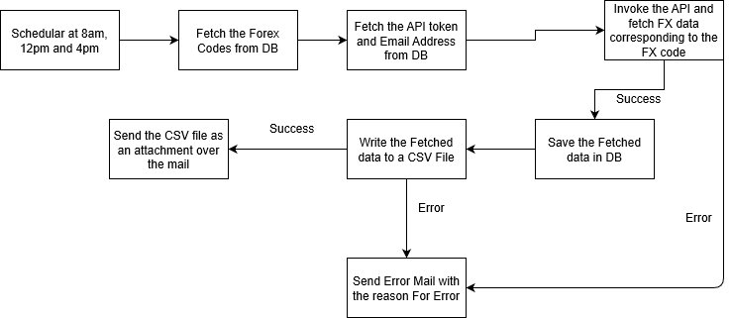

1. **Database Architecture**

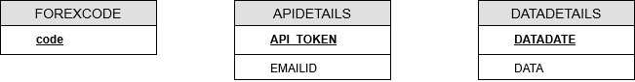

Tables:-

FOREXCODE – To save the codes for which data needs to be fetched

APIDETAILS – Table to save the API token and Email Address to whom the FX data has to be sent. Multiple Email Address would be comma separated

DATADETAILS – Table to save the data fetched each day and sent as an attachment through email.

1. **Assumptions and Constraints**

Fetched real-time data from the API.

Fetched data from the parameter closed and sent it to the user in the API